Le résumé peut être en français ou en anglais, et ne doit pas dépasser 1 page
au risque d'être tronqué arbitrairement.
Vous ne devez utiliser que les styles qui sont compris dans ce modèle.
Les figures peuvent être en couleur.
Exemple:
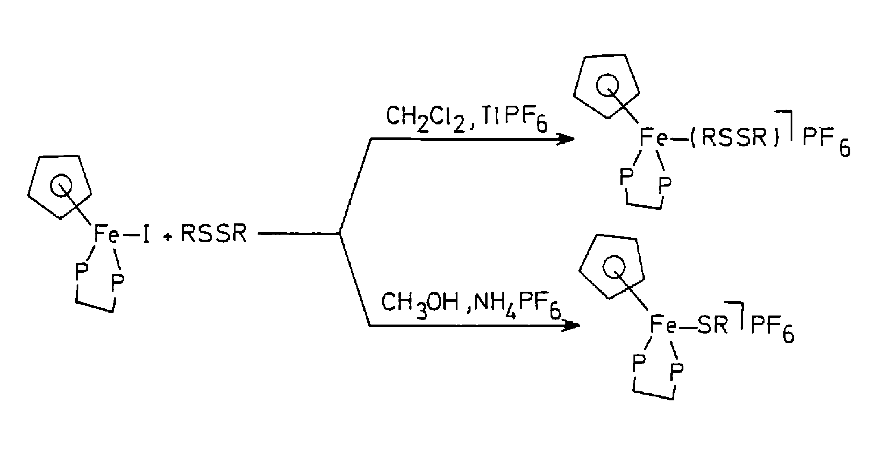Today, metalloenzymes are under very intense scrutiny in several laboratories throughout the world. It is quite clear that inorganic chemistry is being enriched by those biochemical studies, since the role of metal ions in living processes often corresponds to new chemistry. More chemistry has been invented by chance over billions of years than by man in 200 years. Thus the study of metalloenzymes gave a formidable impulse to inorganic chemistry throughout the last 30 years. The reverse is also true: inorganic chemists contributed to the understanding of the metalloenzyme function. Illustrations of the back influence of inorganic chemistry on biochemistry can be found in the work of Groves on hemes 1, Holm on Fe–S clusters 2, Lippard 3 and Que 4 on modelling of di-iron-active site containing enzymes.
Figure 1. Figure qui n'a aucun rapport

A potential application to chemistry resulting from the researches on metalloenzymes is catalysis. It is quite possible to prepare artificial complexes that have a catalytic activity similar to that of metalloenzymes. This has been the case for iron porphyrins able to catalyse the hydroxylation of alkanes as inspired from CytP450 5, for iron complexes able to catalyse the oxidative cleavage by dioxygen of catechols as do intradiol catechol dioxygenases 6 and for Cu-phenolato complexes catalysing the oxidation by air of alcohols into aldehydes 7, so mimicking galactose oxidase(…).

- M. de La Fayette, Inorg. Chem., 1678,1,1010-1200.
- Ling, R.; Yoshida, M.; Mariano, P. S. J. Org. Chem. 1996, 61, 4439–4449.
- Haslam, E. Shikimic Acid Metabolism and Metabolites; John Wiley & Sons: New York, 1993.

